Sedimentary rocks (G202)

By Prof .Dr. Mohanad Al-Jaberi

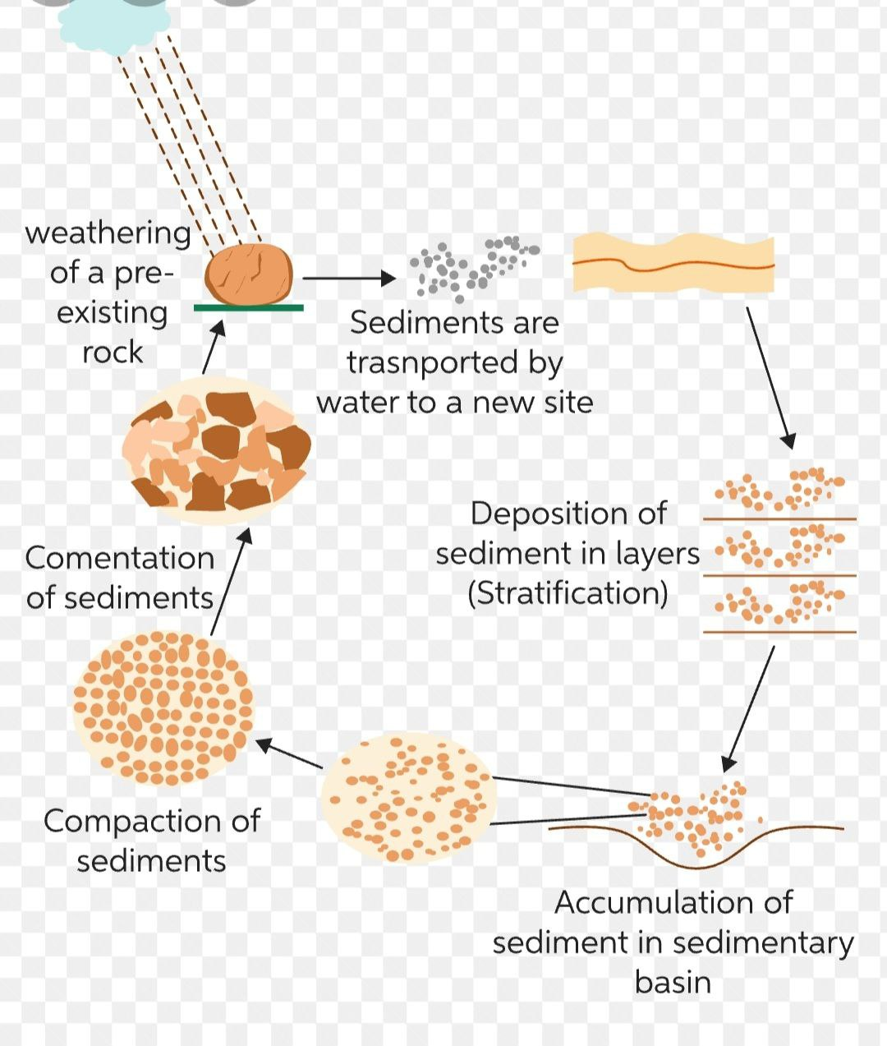

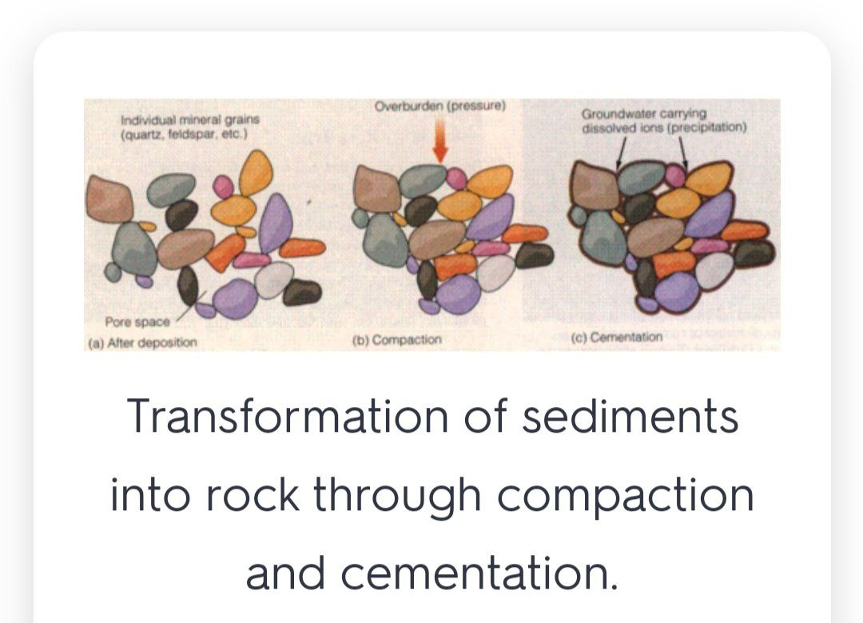

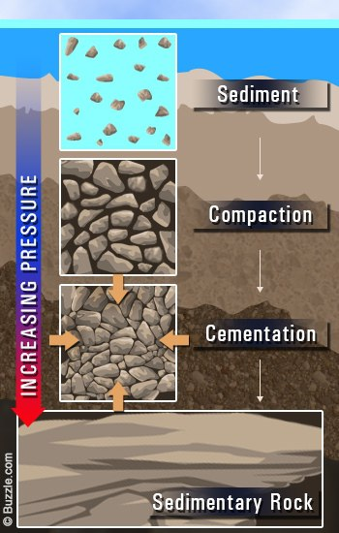

Sedimentary structures are the larger, generally three-dimensional physical features of sedimentary rocks; they are best seen in outcrop or in large hand specimens rather than through a microscope. Sedimentary structures include features like bedding, ripple marks, fossil tracks and trails, and mud cracks.

Considerable attention is paid to the sedimentary structures exhibited by any sedimentary rock. Primary sedimentary structures are particularly useful because their abundance and size suggest the probable transporting and depositional agents. Certain varieties of primary sedimentary structures like cross-bedding and ripple marks display orientations that are consistently related to the direction of current movement. Such structures are referred to as directional sedimentary structures because they can be used to infer the ancient paleocurrent pattern or dispersal system by which a sedimentary rock unit was deposited. Other sedimentary structures are stratigraphic “top and bottom” indicators. For example, the progressive upward decrease in clastic grain size diameters, known as graded bedding, would allow a geologist to determine which way is stratigraphically “up”—i.e., toward the younger beds in a dipping sedimentary bed.

Graded bedding simply identifies strata that grade upward from coarse-textured clastic sediment at their base to finer-textured materials at the top

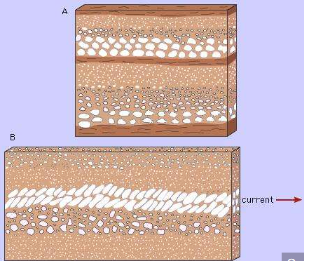

Imbricate bedding is a shingle structure in a deposit of flattened or disk-shaped pebbles or cobbles (Figure 3). That is to say, elongated and commonly flattened pebbles and cobbles in gravelly sediment are deposited so that they overlap one another like roofing shingles. Imbricate bedding forms where high-velocity currents move over a streambed or where strong currents and waves break over a gradually sloping beach, thereby forming beach shingle.
Ripple marks usually form in conditions with flowing water, in the lower part of the Lower Flow Regime. There are two types of ripple marks:
Symmetrical ripple marks
Often found on beaches, they are created by a two way current, for example the waves on a beach (swash and backwash). This creates ripple marks with pointed crests and rounded troughs, which aren't inclined more to a certain direction. Three common sedimentary structures that are created by these processes are herringbone cross-stratification, flaser bedding, and interference ripples.
Asymmetrical ripple marks
These are created by a one way current, for example in a river, or the wind in a desert. This creates ripple marks with still pointed crests and rounded troughs, but which are inclined more strongly in the direction of the current. For this reason, they can be used as palaeocurrent indicators.
• Sole markings form when an object gouges the surface of a sedimentary layer; this groove is later preserved as a cast when filled in by the layer above. They include:
- Flute casts are scours dug into soft, fine sediment which typically get filled by an overlying bed. Measuring the long axis of the flute cast gives the direction of flow, with the scoop-shaped end pointing in the upcurrent direction and the tapered end pointing downcurrent (paleoflow direction). The convexity of the flute cast also points stratigraphically down.
- Tool marks are a type of sole marking formed by grooves left in a bed by objects dragged along by a current. The average direction of these can be assumed to be the axis of flow direction.

• Mudcracks form when mud is dewatered, shrinks, and leaves a crack. This tells you that the mud was saturated with water and then exposed to air. Mudcracks curl upwards,
Cross-bedding
Cross-bedding is the layering of beds deposited by wind or water inclined at an angle as much as 35° from the horizontal.^{[1]} Cross-beds form when sediment particles are deposited on steeper slopes os sand dunes on land or of sandbars in rives and on the seafloor.^{[1]} Cross-bedding in wind-deposited dunes can be complex as a result of fast changing wind directions

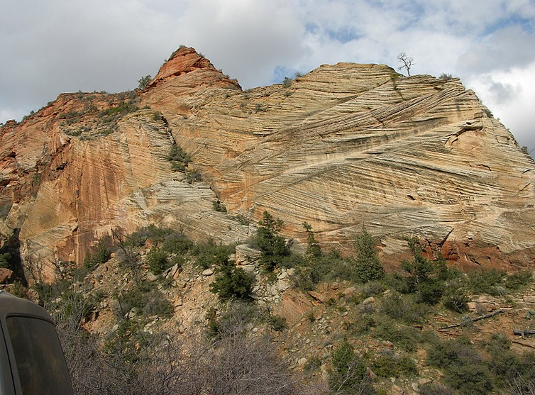

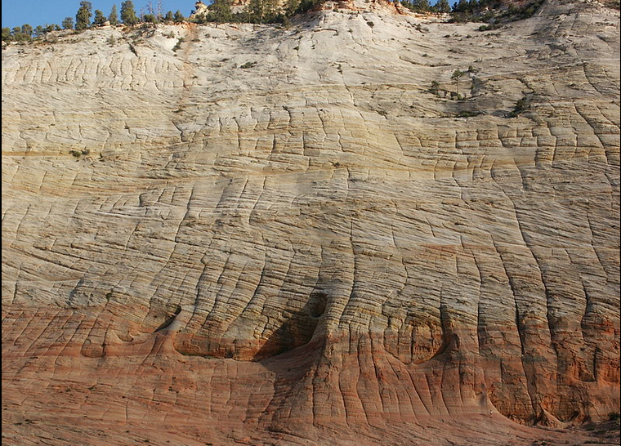

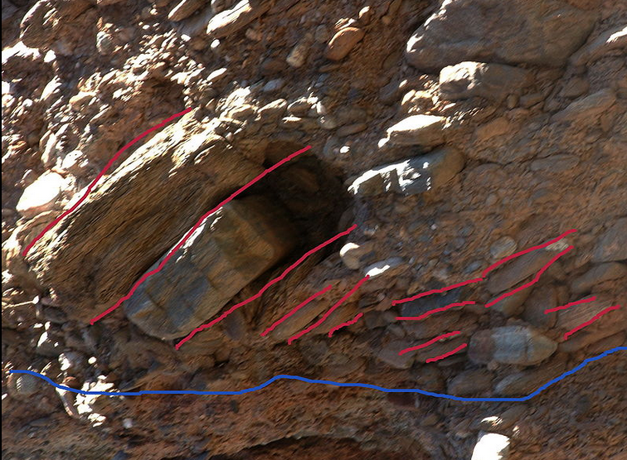

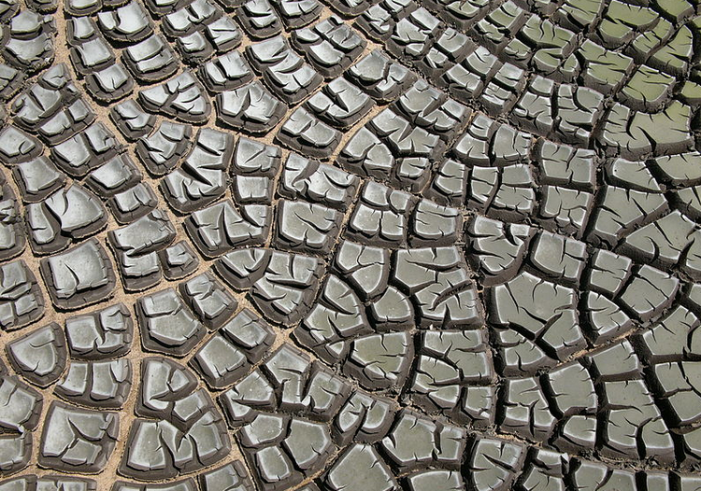

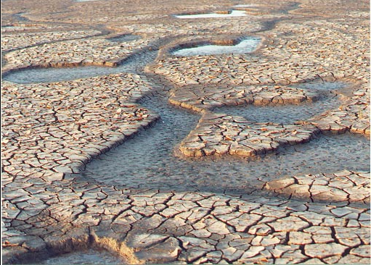

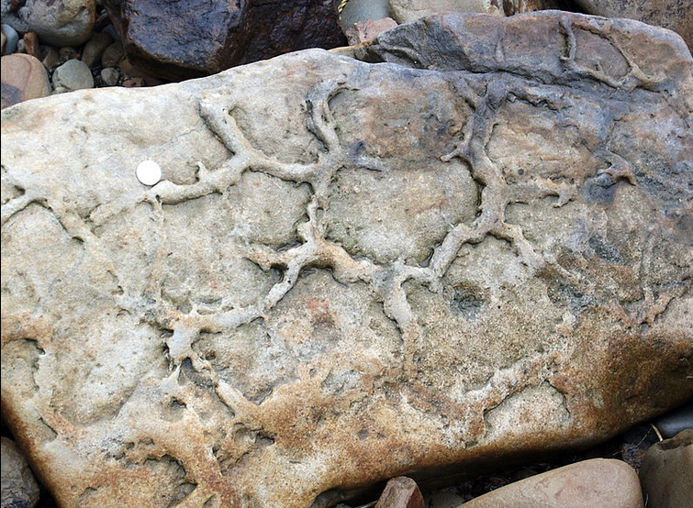

Ancient mudcracks preserved on the base of a bed of sandstone

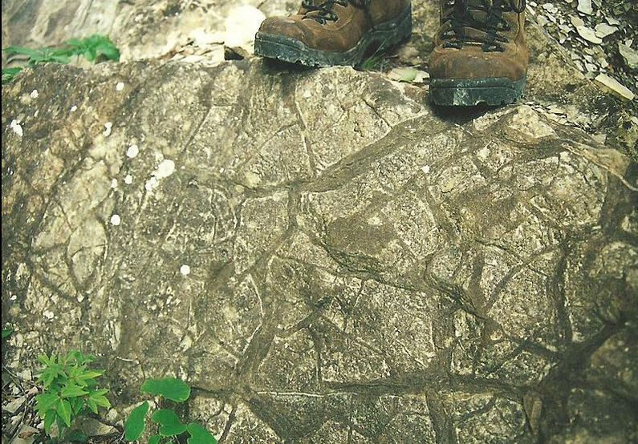

Hummocky cross-stratification is a type of sedimentary structure found in sandstones. It is a form of cross-bedding usually formed by the action of large storms, such as hurricanes. It takes the form of a series of "smile"-like shapes, crosscutting each other. It is only formed at a depth of water below fair-weather wave base and above storm-weather wave base. They are not related to "hummocks" except in shape.

During ancient times, hummocky cross-stratification was located in shallow marine environments, on the shore face and shelf by waves. It can also form on land during especially large storms when large amounts of water are pushed up onto the tidal flat. These landward deposits feature smaller bed forms due to the attenuation of storm waves as they move onto the land. While it is usually formed in marine settings by the action of storms (e.g.hurricane) it may also be deposited in fluvial strata; a fluvial origin is more likely if the unit solely comprises sand

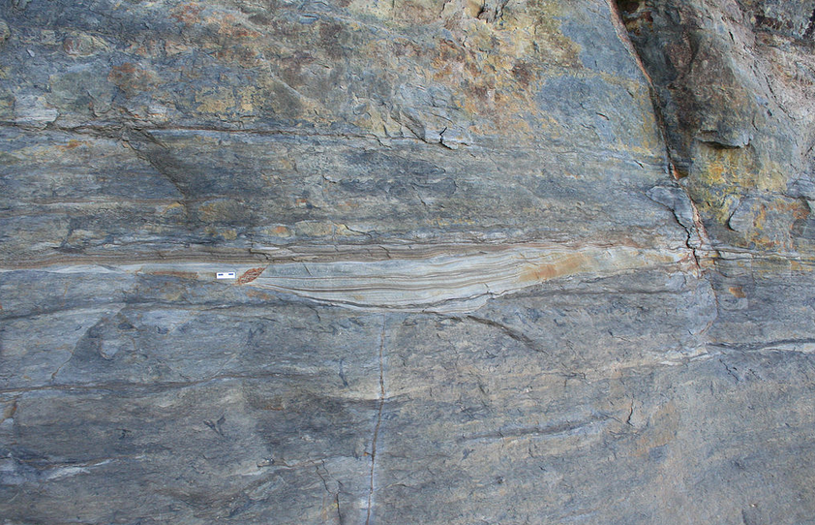

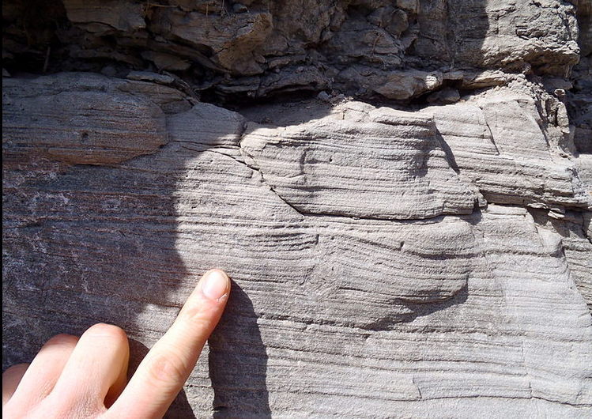

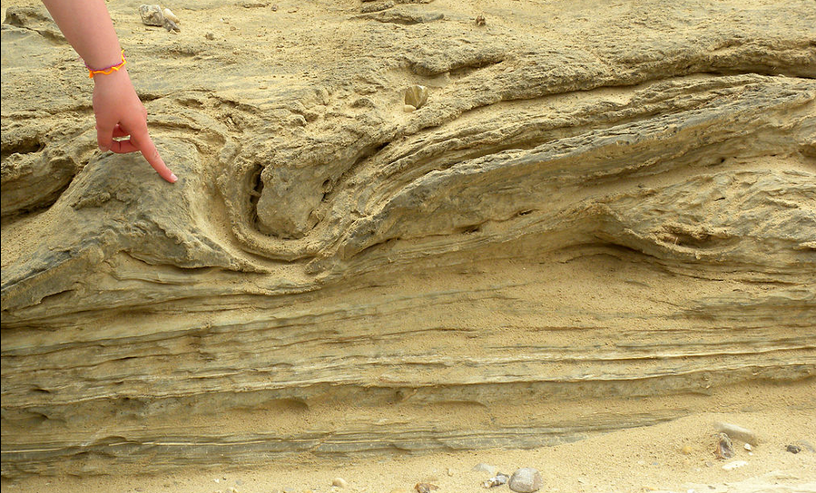

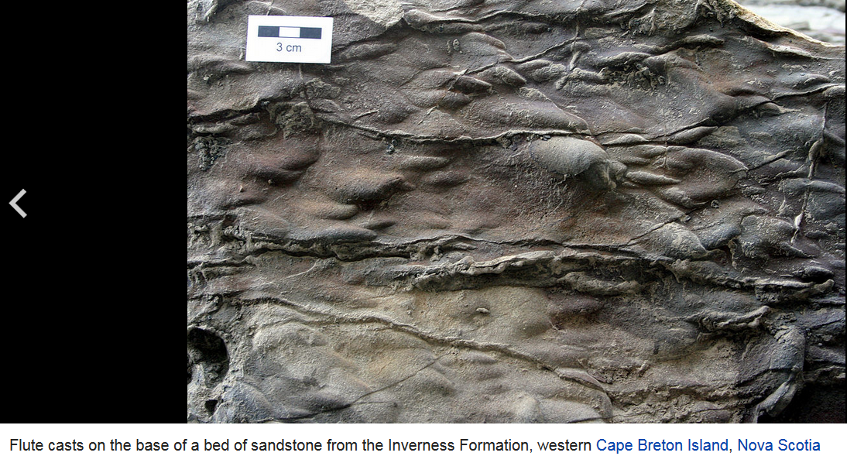

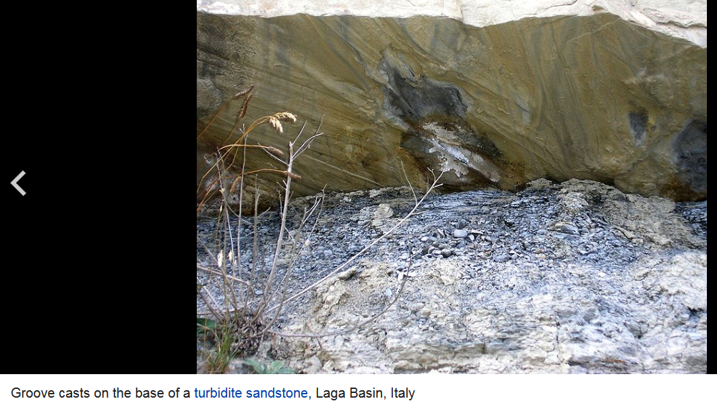

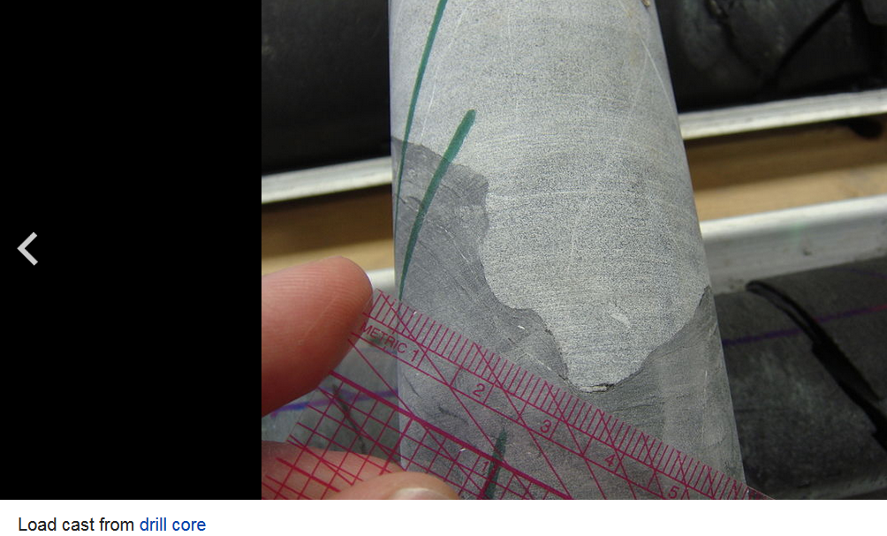
Sole marks are sedimentary structures found on the bases of certain strata, that indicate small-scale (usually on the order of centimetres) grooves or irregularitiesThis usually occurs at the interface of two differing lithologies and/or grain sizes. They are commonly preserved as casts of these indents on the bottom of the overlying bed (like flute casts). This is similar to casts and molds in fossil preservation. Occurring as they do only at the bottom of beds, and their distinctive shapes, they can make useful way up structures and paleocurrent indicators.

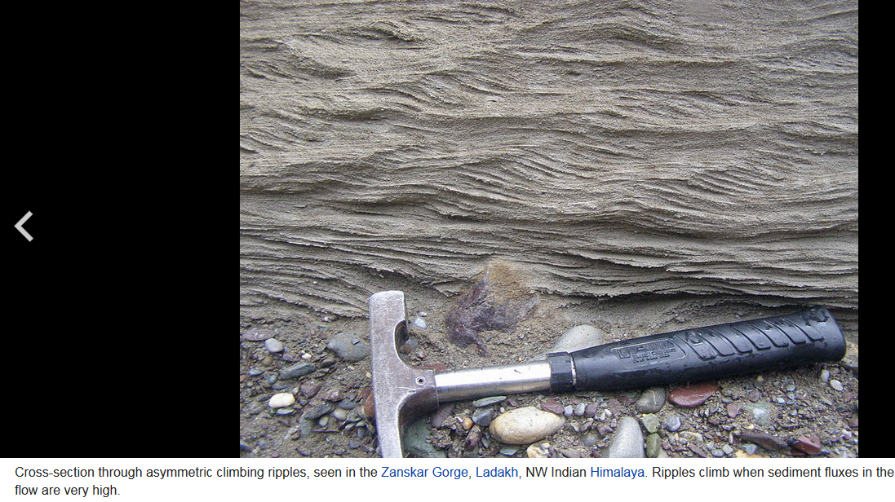

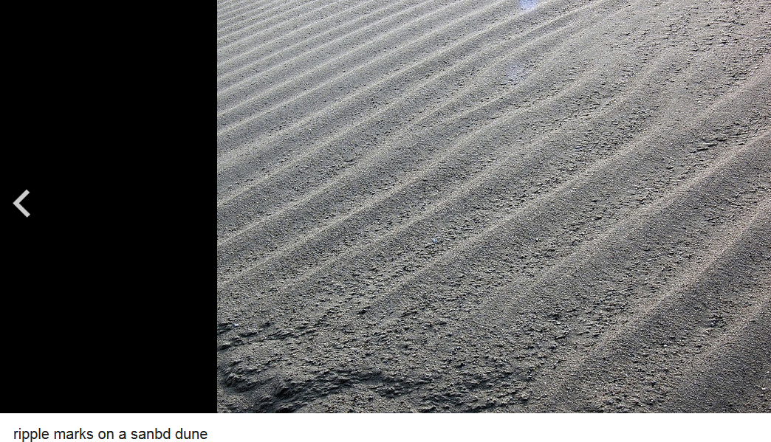

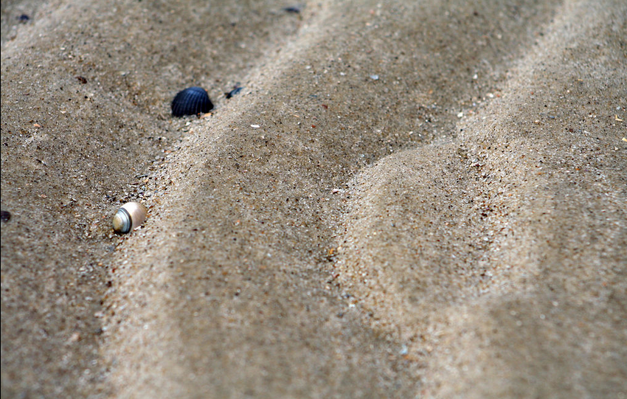

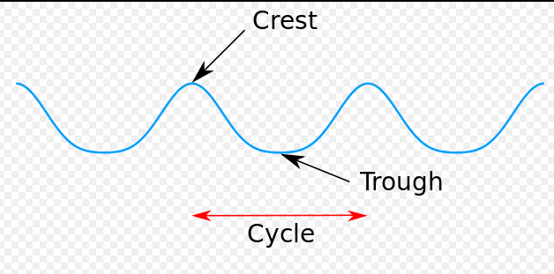

Grain size and sorting

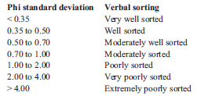

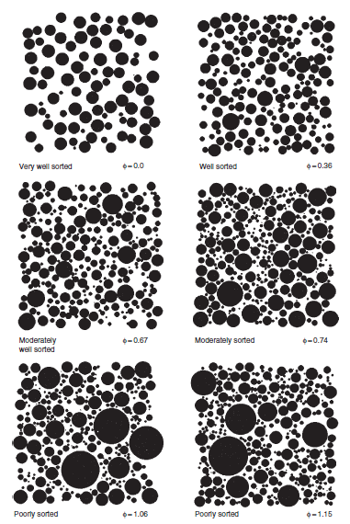
Form refers to the gross, overall morphology or configuration of
particles. Most measures of form consider the three-dimensional shape of the grains.
Roundness is a measure of the sharpness of the corners of a grain, and is commonly measured in two dimensions only.
Surface texture refers to microrelief features, such as scratches and pits, that appear on the surfaces of clastic particles, particularly particles that
have undergone transport. Changes in form or roundness brought about by abrasion during sediment transport or solution or cementation during diagenesis can affect surface texture by creating new grain surfaces.
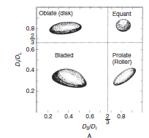

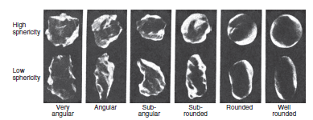
Concept of textural maturity
Sedimentologists often use the term textural maturity in reference to the textural characteristics of a particular sediment. Textural maturity of sandstones encompasses three textural properties: (1) the amount of clay-size sediment in the rock, (2) the sorting of the framework grains, and (3) the rounding of the framework grains. Stages of textural maturity: immature, submature, mature, and supermature
. Any sandstone containing considerable clay, say more than 5 percent, is in the immature stage. Also, the framework grains in immature sediments are poorly sorted and poorly rounded. Presumably, immature sediments have not undergone sufficient sediment transport and reworking to remove fine-size material and produce sorting and rounding of grains. With additional sediment transport and reworking, sediments enter the submature stage, in which the sediments are characterized by low clay content but grains are still not well sorted or well rounded. This stage is followed by the mature stage, in which clay content is low and framework grains become well sorted but are not yet well rounded. Sediments in the supermature stage are essentially clay-free, and framework grains are both well sorted and well rounded. The textural maturity concept is a useful one for characterizing sediments; however, to attribute progressive increase in textural maturity primarily to increasing total input of modifying kinetic energy is probably overly simplistic.

Fabric refers to the textural characteristics displayed by aggregates of grains. Fabric
encompasses two properties of grain aggregates: grain packing and grain orientation. Grainpacking is a function of the size and shape of grains and the postdepositional physical and chemical processes that bring about compaction of sediment. Grain orientation is mainly a function of the physical processes and conditions operating at the time of deposition; however, original grain orientation can be modified after deposition by the activities of organisms (bioturbation) and to some extent by the processes of compaction during diagenesis.

Grain packing refers to packing as “the manner of arrangement or spacing of the solid particles in a sediment or sedimentary rock…; specifically, the arrangement of clastic grains entirely apart from any authigenic grains that may have crystallized between them. Whatever its definition, packing is regarded to be a function of several variables or properties, including particle size and sorting, particle shape, and particle orientation or arrangement.

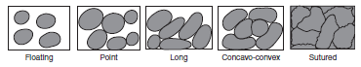

Platy, flaky, or elongated particles in sedimentary rocks commonly display some degree of orientation that reflects the nature of the depositional process. For example, small platy or flaky particles settling from suspension onto a flat bed in the absence of current flow are commonly deposited with their flattened dimensions parallel to bedding surfaces. Small elongated grains settling under the same conditions also tend to have their long dimensions oriented approximately parallel to the bedding surface; however, the grains may have any orientation (random arrangement) within the bedding plane. Small or large particles transported and deposited by traction currents or by sediment gravity flows generally display an orientation that reflects the flow direction of the depositing current. Thus, particles may be oriented with long or flattened dimensions parallel to bedding but have orientations within the bedding plane that are either parallel to current flow.

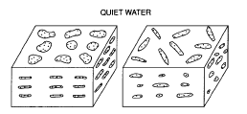

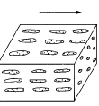

Silica Polymorphs
Quartz is just one of 11 crystalline and 2 non-crystalline polymorphs (also called modifications) of the compound silica, SiO₂. 12 of these modifications can be found in nature, and 11 of them on Earth. All silica minerals are united in the silica group according to Dana's classification, and in the quartz group] according to Strunz's classification.
SiO₂ Polymorphs
Silica Polymorphs (Network Silicates)  Quartz, Low-Quartz, α-Quartz, Alpha-Quartz  High Quartz, β-Quartz, Beta-Quartz  α-Tridymite, Low-Tridymite  β-Tridymite, High-Tridymite  α-Cristobalite, Low-Cristobalite  β-Cristobalite, High-Cristobalite  Moganite (Lutecite, Lutecine)  Coesite  Keatite | Non-Silica Polymorphs  Stishovite  Seifertite
Non-Crystalline Mineraloids
Opal (contains water), with 2 microcrystalline and 2 non-crystalline variants
Lechatelierite, Silica Glass
Related Compounds
Melanophlogite (not pure SiO₂)
Chibaite, IMA2008-067 (not pure SiO₂)
Silhydrite (not pure SiO₂, contains crystal water)
The basic structural element of silica is the SiO₄ tetrahedron. Quartz consists of interconnected SiO₄ tetrahedra that build up a rigid three-dimensional network. There are many possible ways of connecting SiO₄ tetrahedra different from that found in quartz, realized in various other silica polymorphs. Since all of them consist of a three-dimensional SiO₄ network, all are classified as network silicates.
Stishovite and Seifertite are special cases because they are not made of SiO₄ tetrahedra and accordingly are not classified as a network silicates. Instead, each silicon atom is surrounded by 6 oxygen atoms, and the packing of atoms is much more dense.

Dependence of Structure on Temperature
Of all silica polymorphs, quartz is the only stable form at normal ambient conditions, and all other silica polymorphs will - given sufficient time - eventually transform into quartz. The other polymorphs are stable at different and sometimes very special conditions, mostly high temperatures and high pressures, but some of them may also form at low temperatures and pressures under conditions where quartz is stable.
In theory, at normal pressure trigonal quartz (α-quartz) will transform into hexagonal β-quartz at 573°C, upon further heating the SiO₂ will transform into hexagonal β-tridymite at 870°C and later to cubic β-cristobalite at 1470°C. At 1705°C β-cristobalite finally melts:
 | 573°C |  | 870°C |  | 1470°C |  | 1705°C
α-Quartz  trigonal  2.65 g/cm³ |  | β-Quartz  hexagonal  2.53 g/cm³ |  | β-Tridymite  hexagonal  2.25 g/cm³ |  | β-Cristobalite  cubic  2.20 g/cm³ |  | Silica Melt
However, tridymite does usually not form from pure β-quartz, one needs to add trace amounts of certain compounds to achieve this (Heaney, 1994). So the β-quartz-tridymite transition is skipped and the sequence looks like this:
 | 573°C |  | 1050°C |  | 1705°C
α-Quartz  trigonal  2.65 g/cm³ |  | β-Quartz  hexagonal  2.53 g/cm³ |  | β-Cristobalite  cubic  2.20 g/cm³ |  | Silica Melt
The changes in crystal structure lead to changes in the specific density: an increasing temperature corresponds to increasing vibrations of the atoms in the crystal lattice, and as these need more and more space, more open crystal structures are favored. So why don't the atoms form an open structure in the first place? Because the structure must also be in accordance with constraints on the geometry of the covalent bonds, in particular the angled Si-O-Si bond that connects SiO₄ tetrahedra.
As long as the temperature changes very slowly, the whole process is fully reversible.
But things get far more complex when the temperature is increased or decreased more quickly. If one heats up a quartz crystal very quickly, it will still undergo a phase transition to β-quartz, but the β-quartz will then "skip" the transition to β-cristobalite and directly melt at a much lower temperature, at 1550°C.
 | 573°C |  | 1550°C
α-Quartz |  | β-Quartz |  | Silica Melt
It makes sense that β-quartz has a lower melting point: it is less stable than β-cristobalite at that temperature and its crystal lattice is more easily broken up. So it doesn't really make sense to say that quartz melts at 1705°C, because low quartz never melts, and because the melting temperature depends on how quickly you raise the temperature.
However, this process is not reversible. Instead, if a silica melt is cooled quickly, its liquid structure will be preserved and it will turn into amorphous silica glass, called lechatelierite when found in nature. There is no well defined melting point for silica glass which slowly turns into a very viscous liquid upon heating. It is often said (and I've written this before, too) that silica glass is an extremely viscous liquid, just like ordinary window glass, but both glasses are considered as regular solids.
 | 1000 - 1500°C
Silica Glass |  | Silica Melt
Even more strange is what happens to silica glass that is heated up: one would expect it to be converted to β-quartz, β-tridymite or β-cristobalite, depending on the temperature. But in fact it will simply turn into β-cristobalite, just as silica melt would.
 | ca.1000°C |  | 1705°C
Silica Glass |  | β-Cristobalite |  | Silica Melt
This conversion is of technical importance in the industrial production of silica glass, as great care has to be taken to avoid the formation of cristobalite crystals within the glass.
If the polymorphs β-tridymite and β-cristobalite are cooled quickly below the respective transition temperatures, their crystal structure is first preserved until they will transform into polymorphs with closely related structures, α-tridymite and α-cristobalite, at 114°C and 270°C, respectively:
 | 114°C
α-Tridymite |  | β-Tridymite
 | 270°C
α-Cristobalite |  | β-Cristobalite
The transition is fully reversible even at relatively quick temperature changes, just like the transition of α-quartz to β-quartz.
At low pressures there are actually 3 groups of silica polymorphs each of which has 2 closely related members: one low-temperature member given an α-prefix, and one high-temperature member of the same name, but with a β-prefix. Some authors prefer a low-prefix and a high-prefix.
Low Pressure Silica Polymorphs
high- or β-polymorph  stable at  metastable at  crystal system  Si-O-Si angle | β-Quartz  573°C - 870°C  -  hexagonal  153° |  | β-Tridymite  870°C - 1470°C  117°C - 870°C  hexagonal  180° |  | β-Cristobalite  > 1470°C  270°C - 1470°C  cubic  151°
low- or α-polymorph  stable at  metastable at  crystal system  Si-O-Si angle | α-Quartz  < 573°C  -  trigonal  144° |  | α-Tridymite  -  < 117°C  triclinic  140° |  | α-Cristobalite  -  < 270°C  tetragonal  147°
During the transition from a α- to a β-variant the atoms in the crystal lattice only get slightly displaced relative to each other, but they don't change places inside the crystal lattice (the topology is preserved). Because these α-β-transitions are only based on alterations of the angles and the lengths of the chemical bonds, they take place instantaneously. Such a phase transition is generally called displacive, as it only requires relative displacements of the atoms without the need to break chemical bonds. Because the angular Si-O-Si bonds get straightened out, the high-temperature silica polymorphs all possess a higher symmetry than their low-temperature counterparts (hexagonal > trigonal > triclinic; cubic > tetragonal).
All the other transitions of one silica polymorph into another (like from β-quartz to β-tridymite) require the chemical bonds to be broken up and reconnected to alter the crystal structure. Accordingly, such a transition is called reconstructive. In general, complete reconstructive transitions between polymorphs need a lot of time. Quick changes in temperature do not allow for the complete rebuilding of the crystal structure, and the transition will be skipped. This is what happens when β-quartz directly melts at 1550°C without transformation into β-tridymite, and what happens if β-tridymite and β-cristobalite get cooled very quickly. β-tridymite and β-cristobalite can exist outside the temperature range at which they are stable, but as they will very slowly alter to another polymorph that is more stable at those conditions, they are called metastable polymorphs.

Phase Diagram of Silica Polymorphs
Figure 1 shows the temperature and pressure conditions at which SiO₂ polymorphs are stable in a so-called phase diagram of SiO₂. A complete phase diagram would also show the conditions where SiO₂ forms a gas, above 2477°C at normal pressures, but since I don't have data on pressure dependence for that area, this temperature range is omitted.
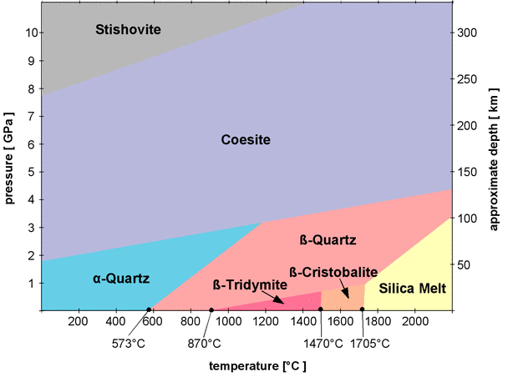
Fig.1: Phase diagram of silica
Data from:
➛Hollemann and Wyberg, 1985
➛Wenk and Bulakh, 2003
➛Rykart, 1995
The phase diagram in Fig.1 does not contain all SiO₂ polymorphs.
• It only shows those polymorphs that form from pure SiO₂ at certain temperatures and pressures.
• It does not show metastable polymorphs.
• It does not show the polymorph seifertite (I don't have any data on its pressure/temperature behavior and its stability field lies well outside the shown temperature/pressure range).
Most of the phase boundaries (the borders between the areas) are inclined to the right. For example, quartz will transform into β-quartz at 573° at normal pressures, but the transition temperature quickly increases with pressure. At a pressure of 2 GPa (Giga pascal, 10⁹ pascal) β-quartz forms at about 1000°C. The rising temperature increases the vibrations of the atoms so they need more space, but the external pressure compresses the crystal lattice and counteracts the effect of temperature^{[4]}.
α-quartz, β-quartz, β-tridymite, and β-cristobalite have already been introduced as low pressure polymorphs, while coesite and stishovite are called high pressure polymorphs and are not stable at normal pressures. Coesite and stishovite have a higher density than the low pressure polymorphs, in particular stishovite, which has a specific density of 4.29 g/cm³. While Coesite is still made of interconnected SiO₄ tetrahedra, stishovite assumes a completely different arrangement of atoms in its crystal lattice. In all low pressure polymorphs as well as in coesite, the silicon atoms are surrounded by 4 oxygen atoms. The silicon in them is said to have a coordination number of 4. This is also the case in all silicate minerals. The coordination number of stishovite is 6, so the silicon atoms are all surrounded by 6 oxygen atoms. The crystal structure of stishovite does not fit in the classification scheme of silicates, so stishovite could well be considered a non-silicate. Stishovite and coesite are both not stable at normal pressures and normal temperatures, but since their transitions into a low pressure silica polymorphs are reconstructive phase transitions that involve a complete rearrangement of the atoms in the crystal lattice, both are metastable at normal conditions.
lechatelierite
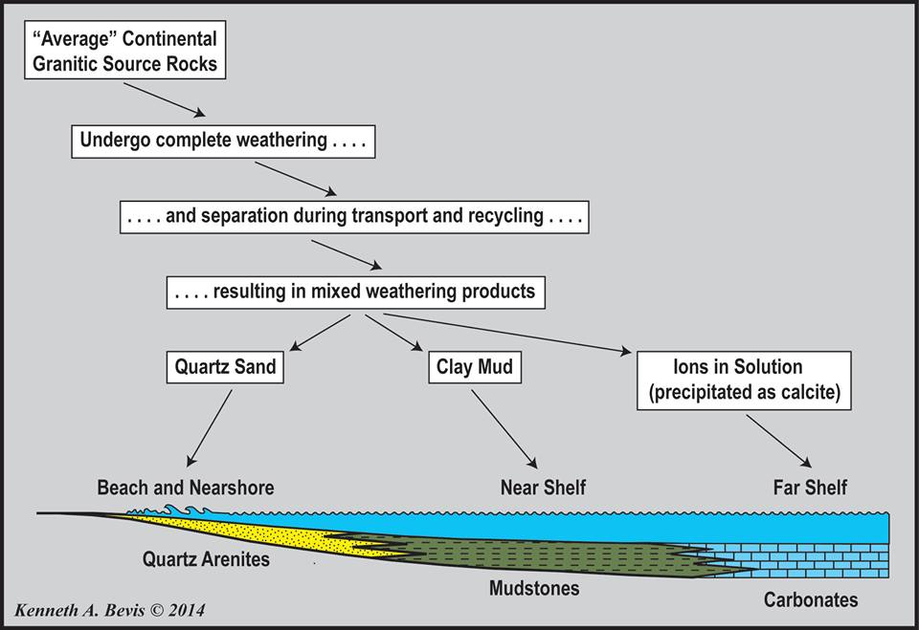
Silt - Clay - Mud - Sand - Soil: What Is The Difference?
Silt is granular material of a size somewhere between sand and clay whose mineral origin is quartz (made up of a continuous framework of SiO4 silicon–oxygen tetrahedra, with each oxygen being shared between two tetrahedra, giving an overall formula SiO2) and feldspar ( KAlSi3O8 – NaAlSi3O8 – CaAl2Si2O8). Silt may occur as a soil or as suspended sediment (also known as suspended load) in a surface water body. It may also exist as soil deposited at the bottom of a water body. silt particles range between 0.0039 to 0.0625 mm or 3.9 and 62.5 micons.
Clays are formed from thin plate-shaped particles held together by electrostatic forces, so present a cohesion. According to the USDA Soil Texture Classification system, the sand-silt distinction is made at the 0.05 mm particle size. The USDA system has been adopted by the Food and Agriculture Organization (FAO). In the Unified Soil Classification System (USCS) and the AASHTO Soil Classification system, the sand-silt distinction is made at the 0.075 mm particle size (i.e. material passing the #200 sieve). Silts and clays are distinguished mechanically by their plasticity (the deformation of a material undergoing non-reversible changes of shape in response to applied forces).
Mud is a mixture of water and some combination of soil, silt, and clay. Ancient mud deposits harden over geological time to form sedimentary rock such as shale or mudstone (generally called lutites). When geological deposits of mud are formed in estuaries the resultant layers are termed bay muds. Mud is closely related to slurry and sediment.
Sand is a naturally occurring granular material composed of finely divided rock and mineral particles. The composition of sand is highly variable, depending on the local rock sources and conditions, but the most common constituent of sand in inland continental settings and non-tropical coastal settings is silica (silicon dioxide, or SiO2), usually in the form of quartz.
The second most common form of sand is calcium carbonate, for example aragonite, which has mostly been created, over the past half billion years, by various forms of life like coral and shellfish. It is, for example, the primary form of sand apparent in areas where reefs have dominated the ecosystem for millions of years, like the Caribbean.
Soil is composed of particles of broken rock that have been altered by chemical and mechanical processes that include weathering, erosion and precipitation. Soil is altered from its parent rock due to interactions between the lithosphere, hydrosphere, atmosphere, and the biosphere.[2] It is a mixture of mineral and organic materials that are in solid, gaseous and aqueous states.[3][4] Soil is commonly referred to as earth or dirt; technically, the term dirt should be restricted to displaced soil.[5]
Soil forms a structure that is filled with pore spaces, and can be thought of as a mixture of solids, water and air (gas). Accordingly, soils are often treated as a three state system. Most soils have a density between 1 and 2 g/cm³. Little of the soil of planet Earth is older than the Tertiary and most no older than the Pleistocene.
Darkened topsoil and reddish subsoil layers are typical in some regions.
On a volume basis a good quality soil is one that is 45% minerals (sand, silt, clay), 25% water, 25% air, and 5% organic material, both live and dead. The mineral and organic components are considered a constant with the percentages of water and air the only variable parameters where the increase in one is balanced by the reduction in the other.

Geologists recognize two categories of weathering processes

- Physical Weathering - disintegration of rocks and minerals by a physical or mechanical process.
- Chemical Weathering - chemical alteration or decomposition of rocks and minerals.
Although we separate these processes, both work together to break down rocks and minerals to smaller fragments or to minerals more stable near the Earth's surface.
Physical Weathering
Physical weathering takes place by a variety of processes. Among them are:
- Development of Joints - Joints are regularly spaced fractures or cracks in rocks that show no offset across the fracture (fractures that show an offset are called faults).
  - Joints form as a result of expansion due to cooling or relief of pressure as overlying rocks are removed by erosion.
  - Joints form free space in rock by which other agents of chemical or physical weathering can enter.
- Crystal Growth - As water percolates through fractures and pore spaces it may contain ions that precipitate to form crystals. As these crystals grow they may exert force an outward that can expand or weaken rocks.
- Heat - Although daily heating and cooling of rocks do not seem to have an effect, sudden exposure to high temperature, such as in a forest or grass fire may cause expansion and eventual breakage of rock. Campfire example.
- Plant and Animal Activities -
  - Plant roots can extend into fractures and grow, causing expansion of the fracture. Growth of plants can break rock
  - Animals burrowing or moving through cracks can break rock.
- Frost Wedging - Upon freezing, there is an increase in the volume of the water (that's why we use antifreeze in auto engines or why the pipes break in New Orleans during the rare freeze). As the water freezes it expands and exerts a force on its surroundings. Frost wedging is more prevalent at high altitudes where there may be many freeze-thaw cycles.

Chemical Weathering
Since many rocks and minerals are formed under conditions present deep within the Earth, when they arrive near the surface as a result of uplift and erosion, they encounter conditions very different from those under which they originally formed. Among the conditions present near the Earth's surface that are different from those deep within the Earth are:
- Lower Temperature (Near the surface T = -20 to 50ºC)
- Lower Pressure (Near the surface P = 1 to several hundred atmospheres)
- Higher free water (there is a lot of liquid water near the surface, compared with deep in the Earth)
- Higher free oxygeon (although O₂ is the most abundant element in the crust, most of it is tied up in silicate and oxide minerals - at the surface there is much more free oxygen, particularly in the atmosphere).
Because of these differing conditions, minerals in rocks react with their new environment to produce new minerals that are stable under conditions near the surface. Minerals that are stable under P, T, H₂O, and O₂ conditions near the surface are, in order of most stable to least stable:

- Iron oxides, Aluminum oxides - such as hematite Fe₂O₃, and gibbsite Al(OH)₃.
- Quartz*
- Clay Minerals
- Muscovite*
- Alkali Feldspar*
- Biotite*
- Amphiboles*
- Pyroxenes*
- Na rich plagioclase*
- Olivine*
Note the minerals with *. These are igneous minerals that crystallize from a liquid. Note the minerals that occur low on this list are the minerals that crystallize at high temperature from magma. The higher the temperature of crystallization, the less stable are these minerals at the low temperature found near the Earth's surface.

The main agent responsible for chemical weathering reactions is water and weak acids formed in water.
- An acid is solution that has abundant free H⁺ ions.
- The most common weak acid that occurs in surface waters is carbonic acid.
- Carbonic acid is produced in rainwater by reaction of the water with carbon dioxide (CO₂) gas in the atmosphere.
H⁺ is a small ion and can easily enter crystal structures, releasing other ions into the water.

Types of Chemical Weathering Reactions
- Hydrolysis - H⁺ or OH⁻ replaces an ion in the mineral. Example:
- Leaching - ions are removed by dissolution into water. In the example above we say that the K⁺ ion was leached.
- Oxidation - Since free oxygen (O₂) is more common near the Earth's surface, it may react with minerals to change the oxidation state of an ion. This is more common in Fe (iron) bearing minerals, since Fe can have several oxidation states, Fe, Fe⁺², Fe⁺³. Deep in the Earth the most common oxidation state of Fe is Fe⁺².
- Dehydration - removal of H₂O or OH⁻ ion from a mineral.
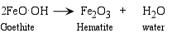
- Complete Dissolution - all of the mineral is completely dissolved by the water.

Weathering of Common Rocks

Rock | Primary Minerals | Residual Minerals* | Leached Ions
Granite | Feldspars | Clay Minerals | Na⁺, K⁺
 | Micas | Clay Minerals | K⁺
 | Quartz | Quartz | ---
 | Fe-Mg Minerals | Clay Minerals + Hematite + Goethite | Mg⁺²
Basalt | Feldspars | Clay Minerals | Na⁺, Ca⁺²
 | Fe-Mg Minerals | Clay Minerals | Mg⁺²
 | Magnetite | Hematite, Goethite | ---
Limestone | Calcite | None | Ca⁺², CO₃⁻²

*Residual Minerals = Minerals stable at the Earth's surface and left in the rock after weathering.

As you can see from the above, clay minerals and oxide minerals (including quartz) are the most common byproducts of chemical weathering. Thus clay minerals and quartz are the most abundant contributors to clastic sediment and soil. We here discuss the structure, properties, occurrence, and identification of clay minerals, but first we need to discuss the phyllosilicates in general.

Clay Minerals
Clay minerals are an important group of minerals because they are among the most common products of chemical weathering, and thus are the main constituents of the fine-grained sedimentary rocks called mudrocks (including mudstones, claystones, and shales). In fact clay minerals make up about 40% of the minerals in sedimentary rocks. In addition, clay minerals are the main constituent of soils. Understanding of clay minerals is also important from an engineering point of view, as some minerals expand significantly when exposed to water. Clay minerals are used extensively in the ceramics industry and are thus important economic minerals.
Based on their structures and chemical compositions, the clay minerals can be divided in to three main classes:
- The kandites based on a structure similar to Kaolinite
- The smectites based on a structure similar to Pyrophyllite
- The illites based on a structure similar to Muscovite
Each of these are formed under different environmental and chemical conditions.

Kandites  The kandites are clays that show a T-O structure , with the octahedral layer similar to the gibbsite structure. Since the layers are electronically neutral, the bonding between layers is by weak van de Waals bonds. Kaolinite is the most common of this group and has the chemical formula Al₂Si₂O₅(OH)₄. Other kandites with similar structures are Anauxite, Dickite, and Nacrite. | 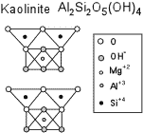

Kaolinite is formed by weathering or hydrothermal alteration of aluminosilicate minerals. Thus, rocks rich in feldspar commonly weather to kaolinite. In order to form, ions like Na, K, Ca, Mg, and Fe must first be leached away by the weathering or alteration process. This leaching is favored by acidic conditions (low pH). Granitic rocks, because they are rich in feldspar, are a common source for kaolinite.
Halloysite, is also a kandite clay, with a structure similar to Kaolinite. However, it has water molecules occurring between the T-O sheets, and has the chemical formula - Al₂Si₂O₅(OH)₄.4H₂O.
Kaolinite, because it does not absorb water, does not expand when it comes in contact with water. Thus, kaolinite is the preferred type of clay for the ceramic industry.

Smectites  The smectite group of clays has a T-O-T structure that is similar to that of Pyrophyllite, but can also have significant amounts of Mg and Fe substituting into the octahedral layers. Thus, the smectites can be both dioctahedral and trioctahedral.  The most important aspect of the smectite group is the ability for H₂O molecules to be absorbed between the T-O-T sheets, causing the volume of the minerals to increase when they come in contact with water. Thus, the smectites are expanding clays. | 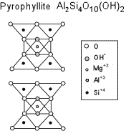

The most common smectite is Montmorillinite, with a general chemical formula :

(½Ca,Na)(Al,Mg,Fe)₄(Si,Al)₈O₂₀(OH)₄.nH₂O
Montmorillinite is the main constituent of Bentonite, derived by weathering of volcanic ash. Montmorillinite can expand by several times its original volume when it comes in contact with water. This makes it useful as a drilling mud (to keep drill holes open), and to plug leaks in soil, rocks, and dams.
Montmorillinite, however, is a dangerous type of clay to encounter if it is found in tunnels or road cuts. Because of its expandable nature, it can lead to serious slope or wall failures.
Other, less common, members of the smectite group include Beidellite, Hectorite, Nontronite, Sauconite, and Saponite.

Illites  The Illite clays have a structure similar to that of Muscovite, but is typically deficient in alkalies, with less Al substitution for Si. Thus, the general formula for the illites is:  K_{y}Al₄(Si_{8-y},Al_{y})O₂₀(OH)₄  usually with 1 < y < 1.5, but always with y < 2.  Because of possible charge imbalance, Ca and Mg can also sometimes substitute for K.  The K, Ca, or Mg interlayer cations prevent the entrance of H₂O into the structure. Thus, the illite clays are non-expanding clays. | 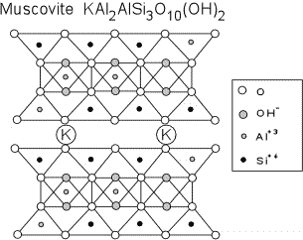

Illite type clays are formed from weathering of K and Al-rich rocks under high pH conditions. Thus, they form by alteration of minerals like muscovite and feldspar. Illite clays are the main constituent of ancient mudrocks and shales.
Mixed Layer Clay
Mixed layer clays are common, and consist of clays that change from one type to another through a stacking sequence. The sequences can be ordered and regular, or high unordered and irregular. For example montmorillinite layers can alternate with illite layers in an ordered way, or there can be several layers of montmorillinite with random layers of illite.

Distinguishing Clay Minerals
Generally, the clay minerals occur as such small mineral grains that they cannot be easily distinguished in either hand specimen or thin section. However, the smectites can be distinguished from the other clays in the field by the "eating test" - place some clay in your mouth. If you can feel it expand as it becomes moistened, then it is one of the smectite clays, and is not a kandite or illite clay.
X-ray techniques, are thus usually required to identify the clay minerals. First, however, the clays have to be separated from other constituents. To do this, we first disaggregate the sample and place it in a settling tube filled with water. Particles will settle in the water according to Stokes Law:
V = 2/9(⟩_{g} -⟩_{w}) g r²/⎜

where
V = the settling velocity
⟩_{g} = density of the mineral grain (2.6 - 2.8 g/cm³ for clay minerals)
⟩_{w} = density of water (1g/cm³)
g = acceleration due to gravity (980 cm/sec²)
r = radius of the mineral particle (10⁻⁴ cm for clays)
⎜ = viscosity of water (10⁻² gcm/sec²)
Usually a desegregating agent (Calgon) is added to the water to keep the individual particles from adhering to one another. The particles are placed in a large glass cylinder filled with water and the desegregating agent, and the mixture is stirred.
One then must use Stokes law to figure out how far particles of clay size will settle in a given time. That distance is measured on the cylinder, and that amount of water is then poured off and collected. It is then poured through a filter to separate the clay minerals from the water. The filter is then dried and the clay minerals are placed on a glass slide ready for X-ray diffraction analysis.
Recall that Bragg's Law:
n⎣ = 2d sin ⎝
allows one to calculate the "d" spacing between lattice planes if the wavelength, ⎣, of the X-rays is known, and the diffraction angle ⎝ is known.
Normally in powder X-ray diffraction studies we would want the mineral grains to be oriented randomly on the glass slide. But for clay minerals, the most diagnostic "d" spacing is between the {001} planes. So, when the grains are placed on the glass slide they are usually placed in a few drops of water so that they will settle onto the slide with their {001} planes parallel to the slide. Thus, when we X-ray them, we get diffraction predominantly off of the {001} planes and can measure the "d" spacing between these planes.
The table below shows the d spacing for the {001} plane as measured for various clay-type minerals. Untreated is for the minerals in their natural state, Ethylene Glycol values are obtained after treating the minerals in a solution of Ethylene Glycol (the principal ingredient in anti-freeze), and the last column show the effect if the mineral is heated to 550ºC after the Ethylene Glycol treatment.

d Spacing on {001} for Clay-Type Minerals (Å)
Mineral | Untreated | Ethylene Glycol | Heated to 550ºC
Kaolinite | 7.1 | No Change | Destroyed
Montmorillinite | 14 - 15 | 17 | 9.5
Illite | 10 | No Change | Little Change
Chlorite | 7 | No Change | 13.2
Mixed Layer | 11 | 12 | 10

Examples of questions on this material that could be asked on an exam
- What is the difference between physical weathering and chemical weathering?
- Give several examples of physical weathering processes.
- What are the conditions near the surface of the earth that differ from those where many minerals originally form?
- What minerals are the most stable under conditions near the surface of the earth?
- What are the three primary types of clay minerals and how do they differ from one another?
- What is the best method for distinguishing the different clay minerals?

Weathering defined as the physical breakdown and chemical alteration of earth materials at or near of earth surface.
During weathering the parent rocks are disaggerated to form small spieces and some of materials are alter or dessolve.
Erosion involve the wearing away of soil and rock by various agents, runnig water, wind, glacial and marine currents.
Transport refer to only of carrying eroded materials.
Type of weathering
- Mechanical weathering
- Chemical weathring

Mechanical weathering or physical weathering is refer to break down the parent material to small pieces with out change in the chemical compostion. While the chemical weathering is the decomposition of rocks that exposure to water and atmospheric gases and form a new chemical composition.
Types of mechanical weathering
1- Frost Wedging - Upon freezing, there is an increase in the volume of the water (that's why we use antifreeze in auto engines). As the water freezes it expands and exerts a force on its surroundings. Frost wedging is more prevalent at high altitudes where there may be many freeze-thaw cycles.

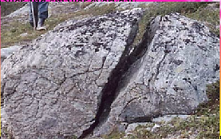

- Development of Joints - Joints are regularly spaced fractures or cracks in rocks .
  - Joints form as a result of expansion due to cooling or relief of pressure as overlying rocks are removed by erosion.
  - Joints form free space in rock by which other agents of chemical or physical weathering can enter.

- Onion-skin weathering (common in desert areas which are hot in day and cool at night)
- rock is repeatedly subjected to heat and cold
- outer layer expands in heat
- outer layer contracts in cold
- outer layer of rock peels off (loose rock known as scree)
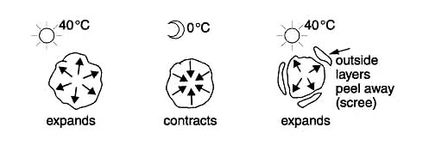
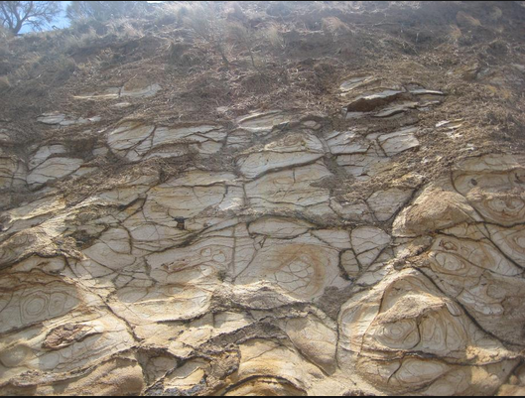

3- Sandblasting processes
Sand move cause to made pits on the surface of rocks.
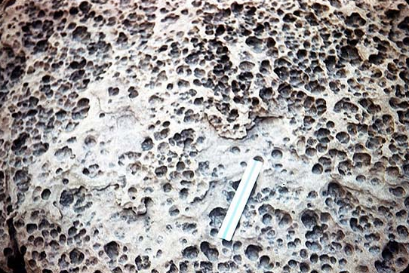
- Pressure release is the reduction of pressure on the rock body , that can be caused to cracks as it expand. It's happened when removal the great weight of batholith as termed unloading , the cracks that caused by expand termed sheet joints that develop parallel to the rock surface, the out part of rocks expand more than the inner part , the sheet joints caused from exfoliation , it's somewhat similar to peeling layers.
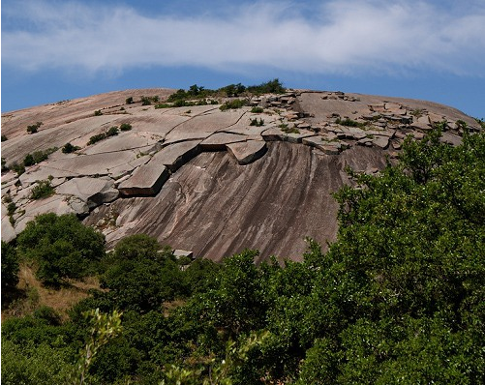

4- Crystal Growth - As water percolates through fractures and pore spaces it may contain ions that precipitate to form crystals. As these crystals grow they may exert force an outward that can expand or weaken rocks.
5-Plant and Animal Activities -
  - Plant roots can extend into fractures and grow, causing expansion of the fracture. Growth of plants can break rock
  - Animals burrowing or moving through cracks can break rock.

بسم الله الرحمن الرحيم
إن الماء إذا بردَّته ينكمش، شأنه كشأن العناصر التي على وجه الأرض، ونقصد بالعناصر، الغازات، والسوائل، والمعادن، الأجسام الصُلبة، إن كل العناصر التي خلقها الله سبحانه وتعالى، تتمدد بالحرارة، وتنكمش بالبرودة، والماء منها، فإذا أردت أن تبرِّد الماء، وكان في درجة الغليان، وراقبت حجمه, بأجهزةٍ حساسة، فإنه ينكمش، إذا انخفضت الدرجة من مئة إلى ستين، إلى أربعين، إلى ثلاثين، إلى عشرين، إلى عشر، إلى خمس، فإذا وصل الماء إلى درجة (+4) عندئذٍ تنعكس الآية، يزداد حجمه ويتمدد, وهذا معاكس للقانون .
القانون المطَّرد الذي ينتظم كل العناصر على وجه الأرض فهو يتمدد، وهذا شيءٌ ترونه أنتم، ضعوا في الثلاجة سائلاً, وراقبوا حجمه، ترونه بعد التجمد يزداد حجمه، فإذا كان قارورةً محكمة السدّ، فإنها تنكسر، هذا شيءٌ معروفٌ لديكم، ولكن ما علاقة هذه الخصيصة بوجود الحياة على وجه الأرض؟ .
قال: إذا تجمدت البحار، لو أن الماء إذا تجمَّد انكمش، أي قلَّ حجمه، فزادت كثافته، فغاص في أعماق البحار، يأتي يومٌ تصبح جميع البحار متجمدةً من سطحها إلى أعماقها، فإذا تجمدت البحار, انعدم التبخر، وإذا انعدم التبخر، انعدمت الأمطار، فماتت النباتات، فمات الحيوان، فمات الإنسان .
أيها الأخوة, لو أن الماء شأنه في التمدد والانكماش كشأن جميع العناصر التي خلقها الله عزَّ وجل، لكانت الحياة قد انتهت منذ ملايين السنين، ولكنَّ ازدياد حجم الماء وتمدده في هذه الدرجة الحرجة، في درجة (+4)، هذه الخصيصة التي أودعها الله في الماء، هي التي تجعل من الحياة مستمرةً على وجه الأرض، فإذا تجمَّدت المحيطات، كان التجمُّد باعثاً على ازدياد حجم الماء، وإذا ازداد حجمه، قلَّت كثافته، وإذا قلت كثافته، طفا على وجه الماء، فلو ذهبنا إلى المحيطات المتجمدة في القطبين، لرأينا التجُّمد في الطبقة السطحية، وأما في أعماق البحر فالمياه سائلة، تسبح فيها الكائنات الحية، كما لو أنها في أماكن أخرى .

Type of chemical weathering
Role of acid
The main agent responsible for chemical weathering reactions is water and weak acids formed in water.
- An acid is solution that has abundant free H⁺ ions.
- The most common weak acid that occurs in surface waters is carbonic acid.
- Carbonic acid is produced in rainwater by reaction of the water with carbon dioxide (CO₂) gas in the atmosphere.
H⁺ is a small ion and can easily enter crystal structures, releasing other ions into the water.
The sequential oxidation of sulfur dioxide followed by its hydration is used in the production of sulfuric acid
SO2 + 2 H2O + O2 → 2 H2SO4

Acid rain is rain that is more acidic than normal. Acid rain is a complicated problem. Primarily caused by air pollution, acid rain's spread and damage involves weather, chemistry, soil, and the life cycles of plants and animals on the land and in lakes and streams.

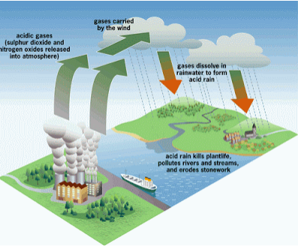

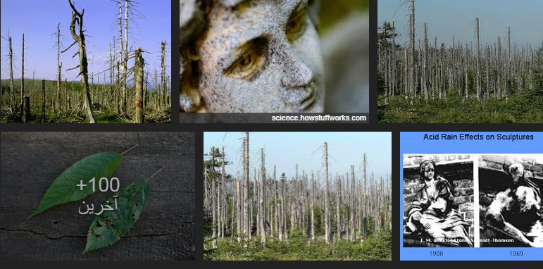
Chemical weathering cause to dessolve the limestone by rainfall to create pits and channels.
Solution weathering
Some mierals are completely dissolved by chemical weathering,
Caco3+ O2+H20
H2Co3+ Ca²

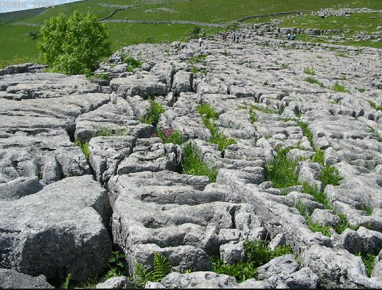
- Hydrolysis - H⁺ or OH⁻ replaces an ion in the mineral. Example:
- Leaching - ions are removed by dissolution into water. In the example above we say that the K⁺ ion was leached.
- Oxidation - Since free oxygen (O₂) is more common near the Earth's surface, it may react with minerals to change the oxidation state of an ion. This is more common in Fe (iron) bearing minerals, since Fe can have several oxidation states, Fe, Fe⁺², Fe⁺³. Deep in the Earth the most common oxidation state of Fe is Fe⁺².
- Dehydration - removal of H₂O or OH⁻ ion from a mineral.
- Complete Dissolution - all of the mineral is completely dissolved by the water.

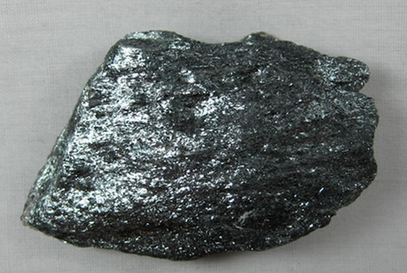
Hematite
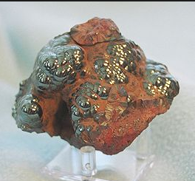
hematite
Spheroidal weathering rocks display interested shapes, this type occur when rocks has been rounded by weathering the initial blocks shape, its rounded because chemical weathering act more rapidly on intensely on the corners and edges of rocks.
Deferential weathering is the term for varying rates of weathering in an area where some rocks are more resistant to weathering than others; resistant rocks weather slowly and may protrude above the softer rocks that weathering rapidly.
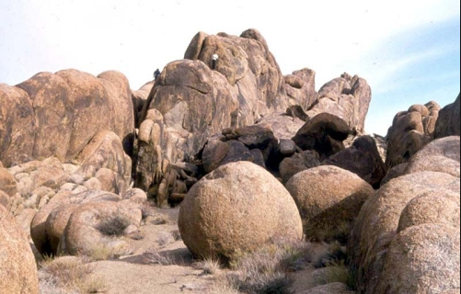

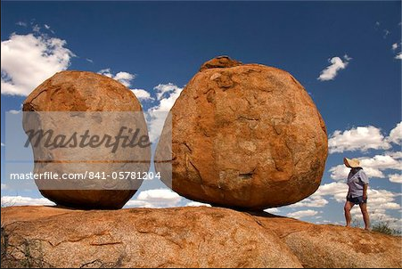
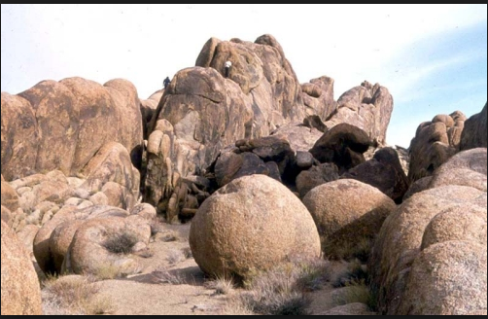
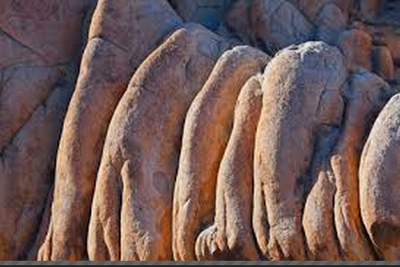
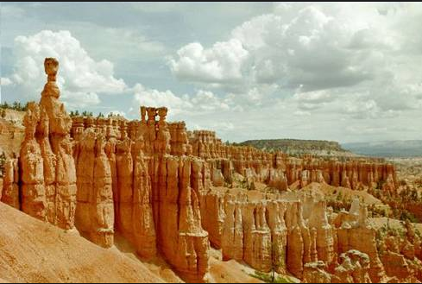
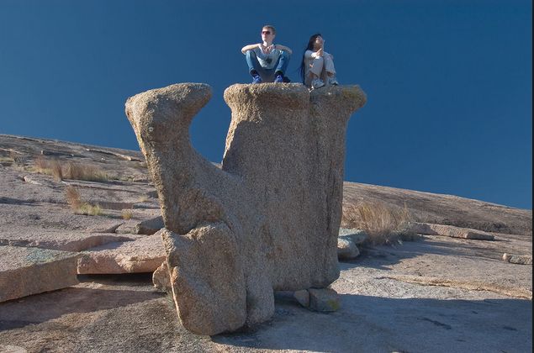
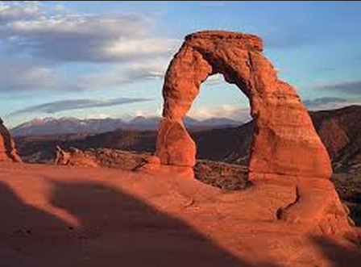

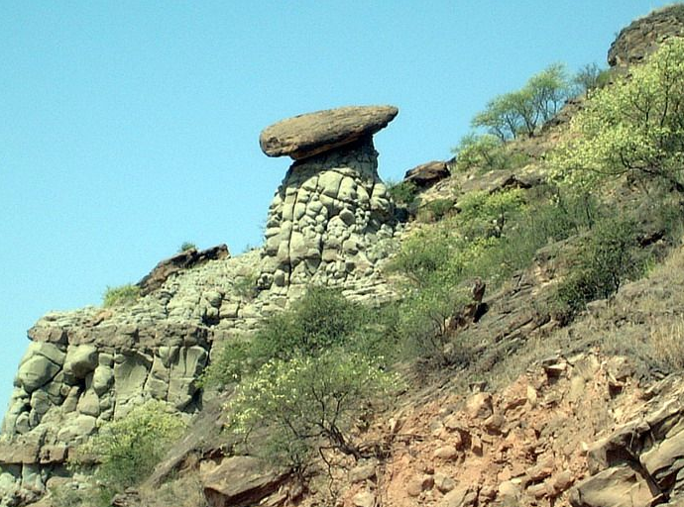

Twinning is a rational symmetrical intergrowth of two individual crystals of the same species. Crystal twinning occurs when two separate crystals share some of the same crystal lattice points in a symmetrical manner. The result is an intergrowth of two separate crystals in a variety of specific configurations. A twin boundary or composition surface separates the two crystals. Twinning is said to be simple if there are two units and multiple if there are many. Simple twinned crystals may be contact twins or penetration twins such as Plagioclase, quartz, gypsum. If several twin crystal parts are aligned by the same twin law they are referred to as multiple or repeated twins such as Albite, calcite, and pyrite.
Texture (or rock microstructure) in geology refers to the relationship between the materials of which a rock is composed, The broadest textural classes are crystalline (in which the components are intergrown and interlocking crystals), fragmental (in which there is an accumulation of fragments by some physical process), aphanitic (in which crystals are not visible to the unaided eye), and glassy (in which the particles are too small to be seen and amorphous arranged).The geometric aspects and relations amongst the component particles or crystals are referred to as the crystallographic texture or preferred orientation. Textures can be quantified in many ways. The most common parameter is the crystal size distribution. This creates the physical appearance or character of a rock, such as grain size, shape, arrangement, and other properties, at both the visible and microscopic scale. An amorphous metal (also known metallic glass or glassy metal) is a solid metallic material, usually an alloy, with a disordered atomic-scale structure. Most metals are crystalline in their solid state, which means they have a highly ordered arrangement of atoms. Amorphous metals are non-crystalline, and have a glass-like structure. But unlike common glasses, such as window glass, which are typically electrical insulators, amorphous metals have good electrical conductivity, The matrix of sedimentary rocks is finer grained sedimentary material, such as clay or silt, in which larger grains or clasts are embedded.
Sedimentary rocks are divided to:
1- Clastic (detrital) sedimentary rocks
2- Chemical sedimentary rocks
3- Organic sedimentary rocks
1- Clastic sedimentary rocks are composed of three main minerals: Quartz, Feldspar and rock fragments
Clastic sed. Rocks are divided to
1- Rudaceous( more than 2mm conglomerate and breccia)
2- Arenaceous from 2- 0.063 mm ( sand stone)
3- Argillaceous less than 0.063 ( silt stone, shale , clay stone and mudstone)
Texture is divided to:
1- Ortho-texture: Its composed on gravel in the young channel stages with matrix less than 15% (grain supported).
2- Para-texture: its form in the old channel stages with relative quiet environment and highly deposits with matrix more than 15% (mud supported).
Gravel deposits are divided to conglomerate and breccia, conglomerate are the most deposits.
Conglomerate is divided according to
A- Composition: 1- Volcanic cataclastic conglomerate 2- carbonate conglomerate 3- Terrigeneous conglomerate
B- Texture : 1- Orth conglomerate ( grain supported) 2- paraconglomerate ( mud supported)
C- Pebbles nature: 1- polymictic conglomerate 2- oligomectic conglomerate
D- pebble source : 1- Intra-formation conglomerate 2- Extra- formation
The difference between conglomerate and breccia is depend on the sorting, porosity, permeability and distance transport.
A concretion is a hard, compact mass of matter formed by the precipitation of mineral cement within the spaces between particles, and is found in sedimentary rock or soil. Concretions are often ovoid or spherical in shape, although irregular shapes also occur. Concretions form within layers of sedimentary strata that have already been deposited, This concretionary cement often makes the concretion harder and more resistant to weathering than the host stratum. concretions form subsequent to burial during diagenesis. They quite often form by the precipitation of a considerable amount of cementing material around a nucleus, often organic, such as a leaf, tooth, and piece of shell or fossil.
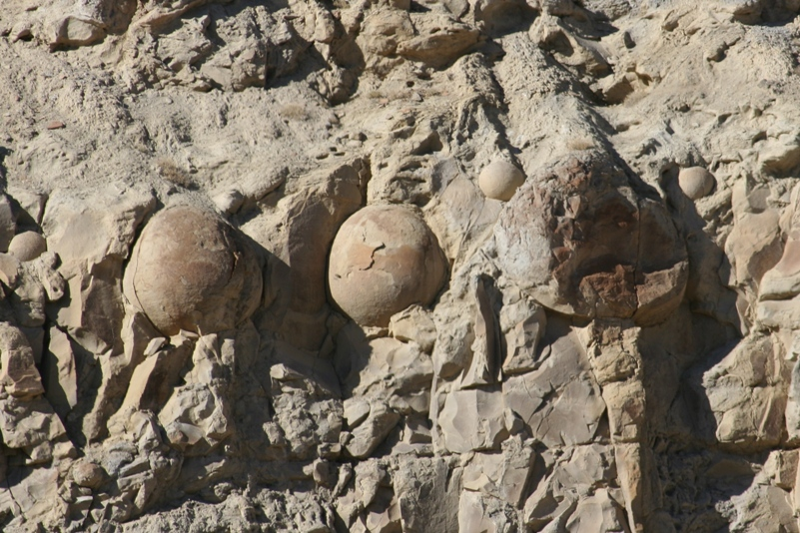
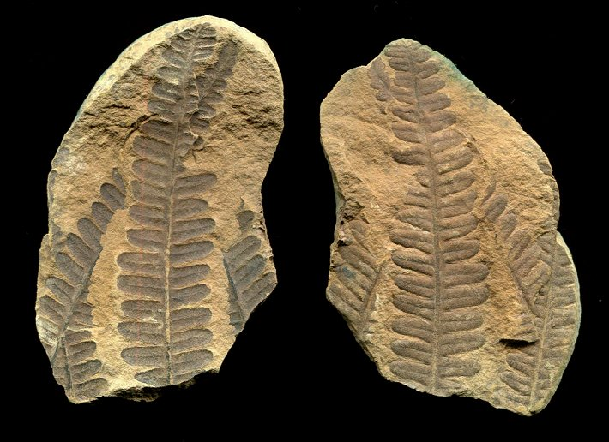
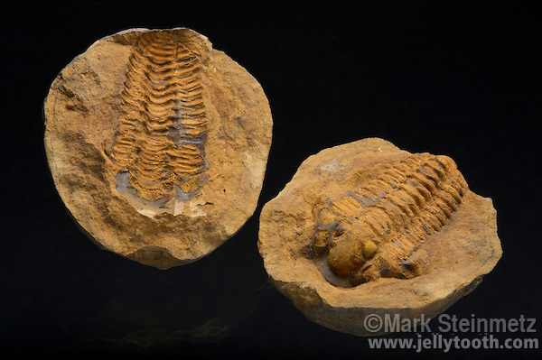
In sedimentology and geology, a nodule is small, irregularly rounded knot, mass, or lump of a mineral or mineral aggregate that typically has a contrasting composition, such as a pyrite nodule in coal, a chert nodule in limestone, or a phosphorite nodule in marine shale, from the enclosing sediment or sedimentary rock. 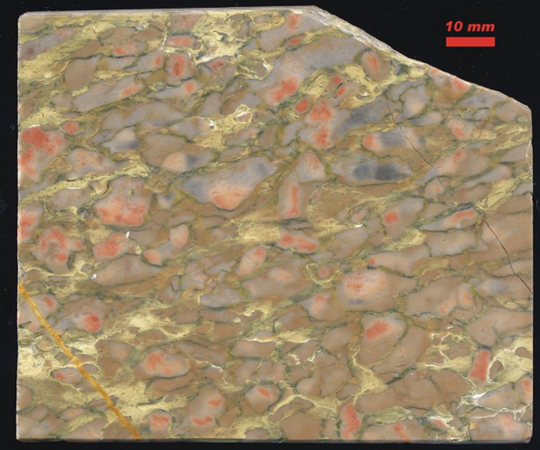 Devonian nodular limestone

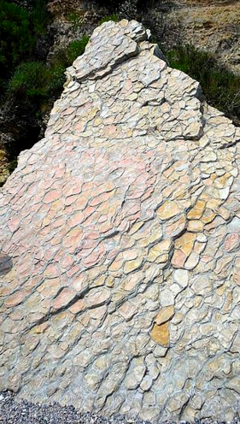
Concretionary nodular limestone
There is an important distinction to draw between concretions and nodules. Concretions are formed from mineral precipitation around some kind of nucleus while a nodule is a replacement body..
Geodes are geological secondary structures which occur in certain sedimentary and volcanic rocks. They are themselves of sedimentary origin formed by chemical precipitation. Geodes are essentially hollow, spheroid to oblate masses of mineral matter that form via either of two processes by the filling of vesicles (gas bubbles) in volcanic to sub-volcanic rocks by minerals deposited from hydrothermal fluids or by the dissolution of sedimentary nodules or concretions and partial filling by the same or other minerals precipitated from diagenetic water, groundwater or hydrothermal fluids.
Quartz mineral
Quartz is one of the most abundant minerals, and as a major constituent in many rocks, it is an important rock-forming mineral. Under conditions at or near the surface, quartz is more stable than most of other minerals and assumes a mostly passive role in the geological environment.
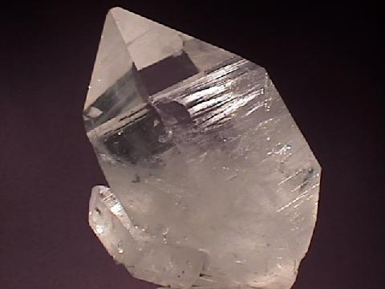

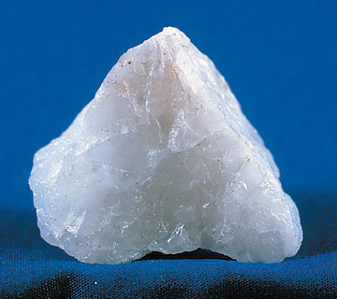
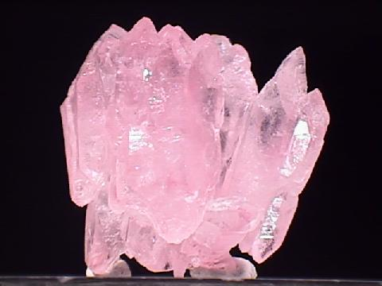
Feldspar mineral
Feldspar forms 5-15% of the terrigenous fraction of sediments, its ease of weathering and lack of durability
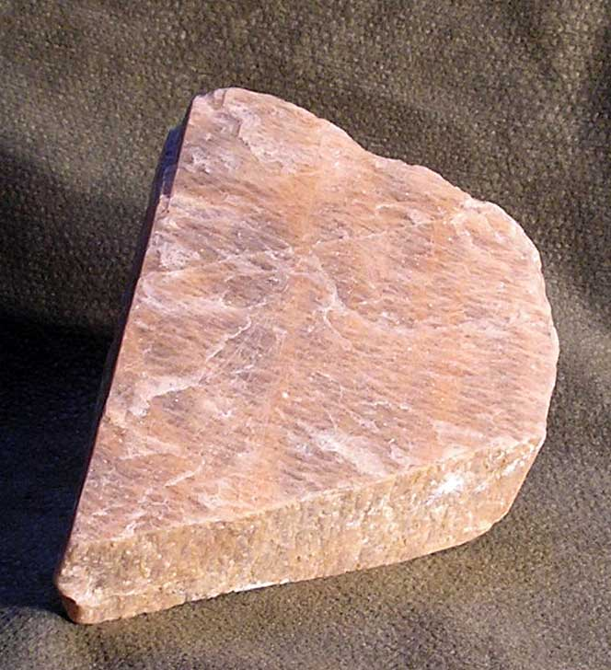
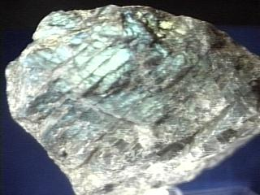
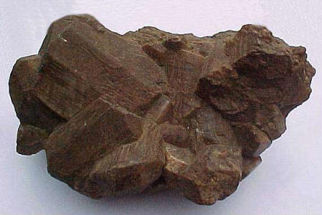
chemical composition, feldspars can be subdivided into two mineral groups – plagioclase feldspars and potassium feldspars, Potassium feldspars are a group of polymorphs, polymorphs being minerals that have the same chemical composition but slightly different crystal structures. Despite their different crystal structures, the potassium feldspars are very similar to one another in appearance, so in the field they are often identified simply as ‘potassium feldspar’. Although their color varies, potassium feldspars typically form pink, reddish or white, hard blocky crystal masses that exhibit cleavage in two directions. The resulting cleavage faces meet nearly at right angles. Potassium feldspars are particularly common in felsic igneous rocks metamorphic rocks, pegmatites (A pegmatite is a holocrystalline,intrusive igneous rock composed of interlocking phaneritic crystals usually larger than 2.5 cm in size;^{[1]} such rocks are referred to as pegmatitic. Most pegmatites are composed of quartz, feldspar and mica, having a similar basic composition as granite. Rarerintermediate composition and mafic pegmatites containing amphibole, Ca-plagioclase feldspar, pyroxene, feldspathoids and other unusual minerals are known, found in recrystallised zones and apophyses associated with large layered intrusions. Crystal size is the most striking feature of pegmatites, with crystals usually over 5 cm in size. Individual crystals over 10 metres across have been found, and many of the world's largest crystals were found within pegmatites. These include, spodumene, microcline, beryl, and tourmaline) and low temperature hydrothermal veins. Potassium feldspars are the feldspar minerals in which the silicate tetrahedral and aluminum tetrahedra are bound with potassium ions, rather than sodium or calcium ions as in the plagioclase feldspar subgroup. The potassium feldspar group is composed of three mineral polymorphs, each having the same chemical composition, but slightly different crystal structures. Technically these are distinct minerals, but their physical properties are so similar that they are usually only identified as ‘potassium feldspar’ in the field. Using other minerals in the rock to determine the host rock’s identity is often the most useful guide to their probable identity.
Mineral: | Color: | Occurrence:
Orthoclase | white or pink | potassium-rich volcanic rocks
Sanidine | colorless | felsic plutonic igneous rocks and metamorphic rocks
Microcline | white, pink  or green | granite, pegmatites, & low temperature  hydrothermal veins

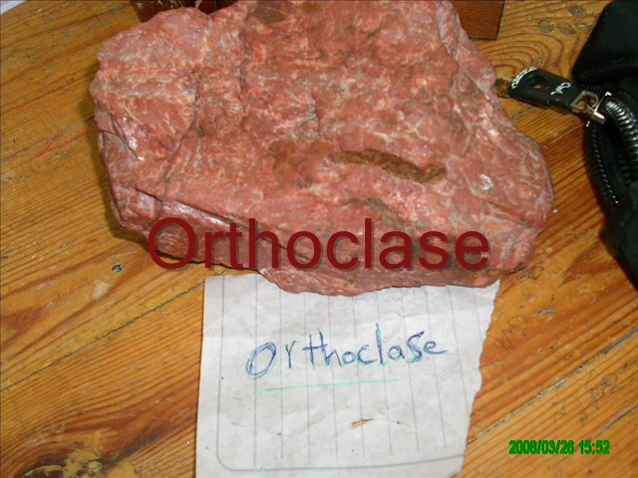
Within the feldspar group, the potassium feldspars are only differentiated from the plagioclase minerals by the lack of fine parallel striations, In general, potassium feldspars commonly have pink to reddish hues, while the plagioclase feldspars tend to be white or gray, but both mineral groups may exhibit similar colors, so the presence or absence of striations is more diagnostic. The crystal structure of the plagioclase and potassium feldspar groups are so similar that the two may develop as thin alternating bands within a single specimen. This mixed variety of feldspar is called perthite.
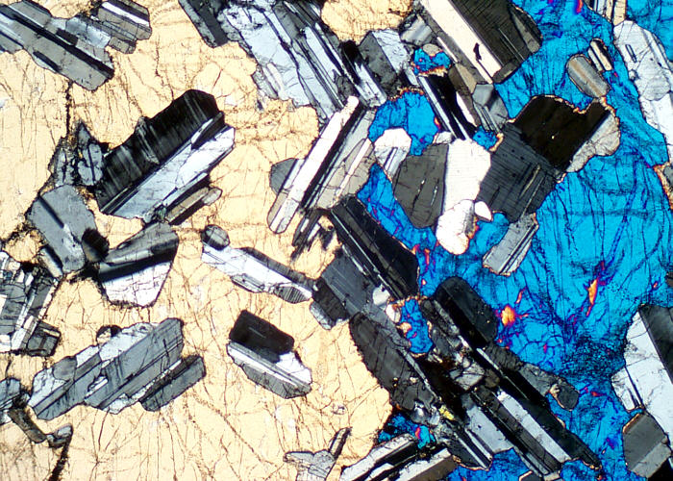
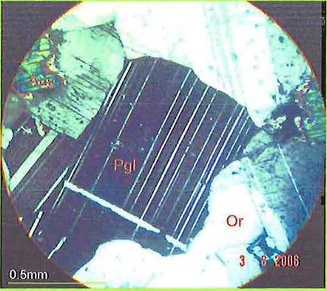
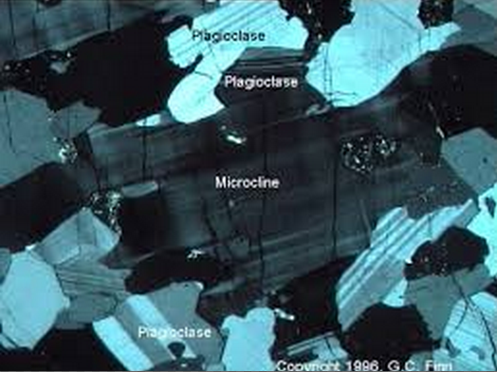

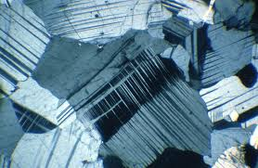
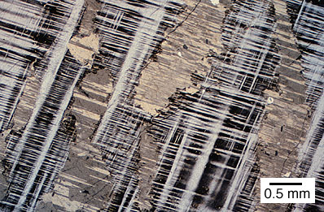

Plagioclase is an important series within the feldspar family, The series ranges from albite to anorthite (with respective compositions NaAlSi₃O₈ to CaAl₂Si₂O₈). Microcline is the stable form below about 400° C. Orthoclase and sanidine are stable above 500° C and 900° C, respectively.
- Albite (An 0–10)(Naalsi3o8)
Oligoclase (An 10–30)
Andesine (An 30–50)
Labradorite (An 50–70)
Bytownite (An 70–90)
Anorthite (An 90–100)(caAlsi3o8)

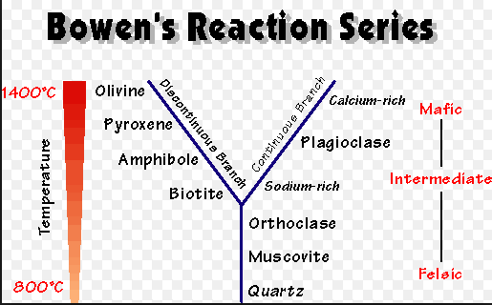

Rock fragments
Rock fragments unattached pieces of rocks of 2 mm diameter or larger , strongly cemented or more resistant to rupture. They are found on the soil surface or distributed in various quantities into the soil body .Rock fragments can be derived from metamorphic , igneous , and sedimentary rocks.

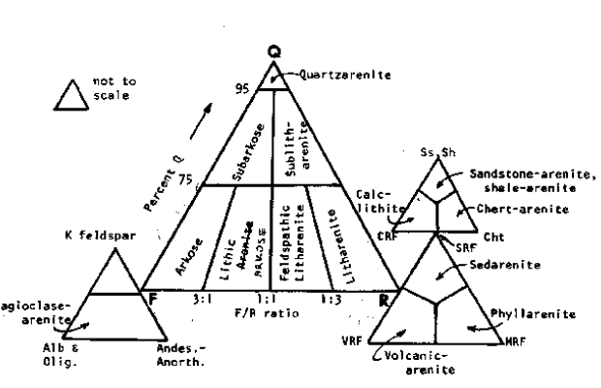

Sandstone: Is formed by the cementation of sand grains , any deposits of sand can lithify to sand stone. River deposits sand in their channels, and wind piles up sand into dunes, wave deposits sand on beaches and in shallow water , deep sea currents spread sand over the sea floor, sandstone one show the great deal of variation in minerals composition , degree of sorting and degree of rounded.
Quartz sandstone or quartizite or quartz arenite , a sandstone in which more 90% of grains are quartz, because quartz is resistant to chemical weathering , it tend to concentrate in sand deposits as the less resistant minerals such as feldspare is weathering a way. The quartz grains in quartz sandstone are usually well-sorted and well rounded because they have been transported for great distance. Most quartz sandstone was deposits as beach sand or sand dune. 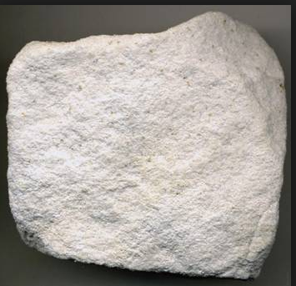
Sand stone with more than 25% of the grains of consisting of feldspar is call Arkose. This rock is not chemical resistant. The clay matrix is lower than 15%. Arkose is not chemical maturity but its physical maturity. It contains angular or sub angular feldspar grains. The color of this rock is red to pink.
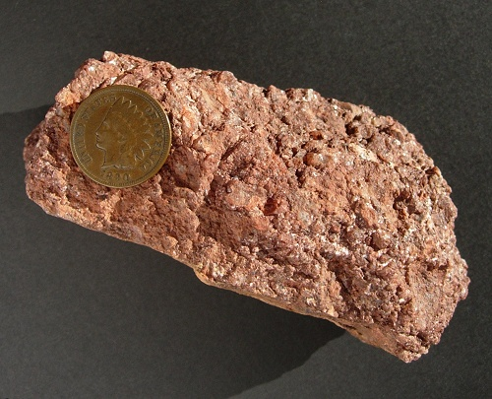
Grey wacke is a type of sandstone in which more than 15% matrix , with 25-60% feldspar. The rock volume consists of fine grained matrix, this rocks are often dense and generally dark grey or green. Most grey wacke probably formed from sediments transported by turbidity currents, dense masses of sediment laden water that flow down slope along the sea floor . The sediments – water mixture is heavier than clean water , so it pulled down slope by gravity until it comes to rest on the sea floor at the base of slope , sediments laden rivers discharging directly into the sea may also caused turbidity currents.
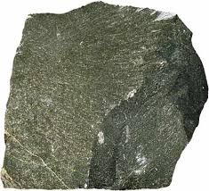
Quartz wacke is the chemical sand maturity, contain less than 15% feldspar, and its non-physical maturity because it's have more than 15% matrix, the color of these rocks are grey to red-brown. These rocks are composed of more than 25% of quartz mineral.
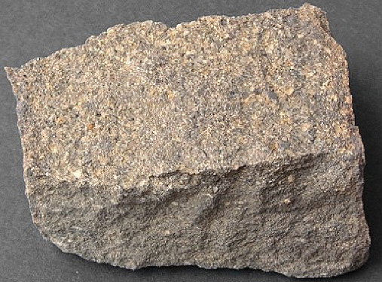

Component of carbonate rocks
1-Grains A- detrital grains Lithoclasts, Intraclasts, sandy limestone B- Skeletal debris, lime mud, Algae
c- Pelloids: is structureless cryptocrystalline carbonate grains between 20-60 micrometer diameter.
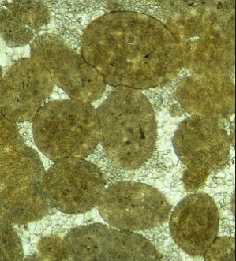

Peloids form in different ways, Pellets are peloids of fecal origin secreted by marine invertebrate.
Pelletoids are peloids formed by the micritization of skeletal grains through the action of algae.
Peloidal deposits form in lagoon.

D- Lumps is composed of several peloids that held together as grapstone.
E-Coated grains is a radial arrangement of carbonate around a nucleus.
Ooids are small (2 mm in diameter), spheroidal, "coated" (layered) sedimentary grains, usually composed of calcium carbonate, but sometimes made up of iron- or phosphate-based minerals. Ooids usually form on sea floor.

Pisoids are similar to ooids, but are larger than 2 mm in diameter, formed in caverns, a rocks composed of Pesoids called Pisolith, form in low anergy.
Oncoids is coated grains in several centimeter in diameter, low energy.
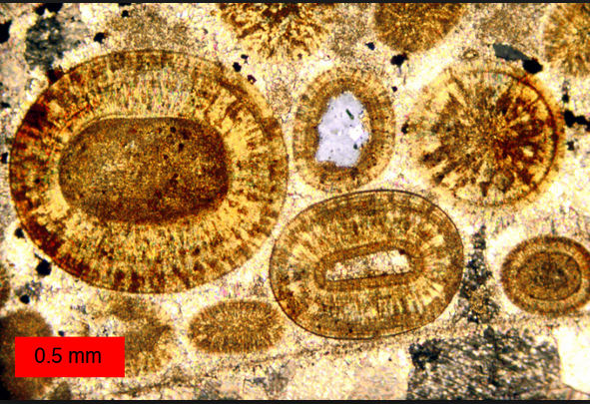

Micrite is carbonate mud with diameter between 0.03-0.04mm (coarse silt), found in low energy.
Sparite is a crystalline materials as a cement with diameter more than 0.105mm (fine sand) (High energy).

Classifications of carbonate rocks

1-Dunhum 1962

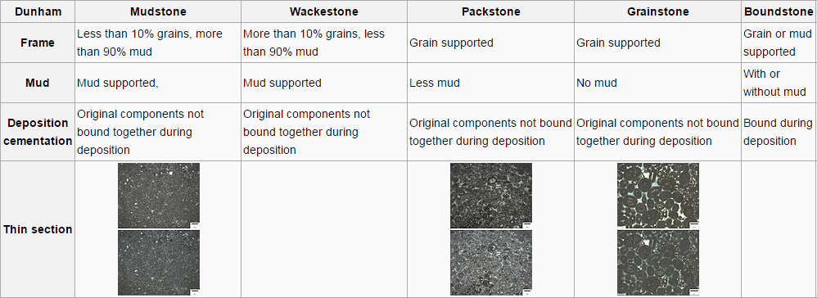
Dunham's classification (figures above) deals with depositional texture. For this reason, his scheme may be better suited for rock descriptions that employ a hand lens or polarize microscope. For example, if the grains of a limestone are touching one another and the sediment contains no mud, then the sediment is called a grainstone. If the carbonate is grain supported but contains a small percentage of mud, then it is known as a packstone. If the sediment is mud supported but contains more than 10 percent grains, then it is known as a wackestone, and if it contains less than 10 percent grains and is mud supported, it is known as a mudstone.
Folk 1974
Folk classification requires definite knowledge and abundances of carbonate grains (allochems) and relative abundance of micrite and sparry calcite cement. Allochems composed of intraclasats , pellets, oolites, shells, and skeletal debris.
If one compares the two classifications, a rock rich in carbonate mud is termed a micrite by Folk and a mudstone or wackestone by Dunham. Moreover, a rock containing little matrix is termed a sparite by Folk and a grainstone or packstone by Dunham.
Grain supported and mud supported
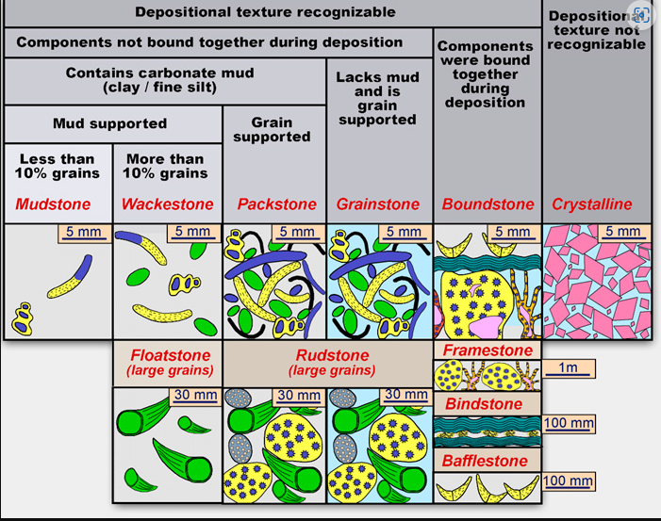
Digenetic in carbonate rocks
- Crystallization is infilling the primary porosity by growth sparite, this result decreased the porosity.
- Polymorphic transformation is one mineral replacement by another.
- Leaching
- Silicification destroy the primary porosity when develop the calcedonic cement.
- Stylolite is a sutured line between two rocks
- Microstylolite
